What is Environmental Management System?

An **environmental management system** (**EMS**) is "a system and database which integrates procedures and processes for training of personnel, monitoring, summarizing, and reporting of specialized environmental performance information to internal and external stakeholders of a firm".The most widely used standard on which an EMS is based is International Organization for Standardization (ISO) 14001. An environmental management information system (EMIS) or Environmental Data Management System (EDMS) is an information technology solution for tracking environmental data for a company as part of their overall environmental management system.  The EMS by itself, does not dictate a level of environmental performance that must be achieved; each organization's EMS is tailored to the its own individual objectives and targets.



Where & how can Environmental Management System be applied?

For **Environmental Management System** (**EMS**), be applied to any organization, irrespective of size or industry sector. EMS principle approach has following basic principles & strategies in place:

|  |  |
| --- | --- |
| Principles – QMS Principles may be considered to maintain  EMS apart from aspect & Impact | Strategies |
| * CUSTOMER FOCUS * LEADERSHIP * ENGAGEMENT OF PEOPLE * PROCESS APPROACH * IMPROVEMENT * EVIDENCED BASED APPROACH * RELATIONSHIP MANAGEMENT | * Focus on the scope & context applicability of EMS; * Identify Aspects & Impacts; * Define Risk Assessment to identify Risk Impact of each Aspect on Environment, w.r.t Time & Loss; * Perform Risk Evaluation (Impact Level) on current controls and after new controls; * Focus the Environmental Controls on the Vulnerability causing the Impacts; * Understand and approve the Residual Risks & Implement the selected controls & monitor for performance |

What can make Environmental Management System journey successful?

To implement & get maximum benefited from EMS, there has to be ***baseline mindset principles***, in which every member of the organization (including Top Management) should believe in:

|  |  |
| --- | --- |
| Mind Set for EMS | Benefits of EMS |
| * Clear understanding the importance of Information and its legitimate usage ! * Open mind to adopt culture for new understanding & learning concepts, technology and its vulnerabilities of the relevant Assets, in more precise manner; * Complete Transparency in understanding, implementing changes, if need be, at appropriate time; * **Always believe that, what we know today is not enough and not the end**; * Always believe in and practice team work, commitment to improve and believe in that: * **Any System to be in such a manner that people depend on System, & not the other way round**”; * Ask self-question all the time - “Am I interpreting the requirements of EMS Standard in current manner?; * Importance has to be given to documentation with Criteria inbuilt into it for internal transparency; * **Believe in building up Process KEDB (Known Error Data Base) – and update in disciplined manner and ensure that this is accessible to every one** | * Serves as a tool, or process, to improve environmental performance and information mainly "design, pollution control and waste minimization, training, reporting to top management, and the setting of goals" * Provides a systematic way of managing an organization's environmental affairs * Is the aspect of the organization's overall management structure that addresses immediate and long-term impacts of its products, services and processes on the environment. EMS assists with planning, controlling and monitoring policies in an organization.[[5]](https://en.wikipedia.org/wiki/Environmental_management_system#cite_note-5) * Gives order and consistency for organizations to address environmental concerns through the allocation of resources, assignment of responsibility and ongoing evaluation of practices, procedures and processes * Creates environmental buy-in from management and employees and assigns accountability and responsibility. * Sets framework for training to achieve objectives and desired performance. * Helps understand legislative requirements to better determine a product or service's impact, significance, priorities and objectives. * Focuses on continual improvement of the system and a way to implement policies and objectives to meet a desired result. This also helps with reviewing and auditing the EMS to find future opportunities. * Encourages contractors and suppliers to establish their own EMS. |

What is Annexure L?

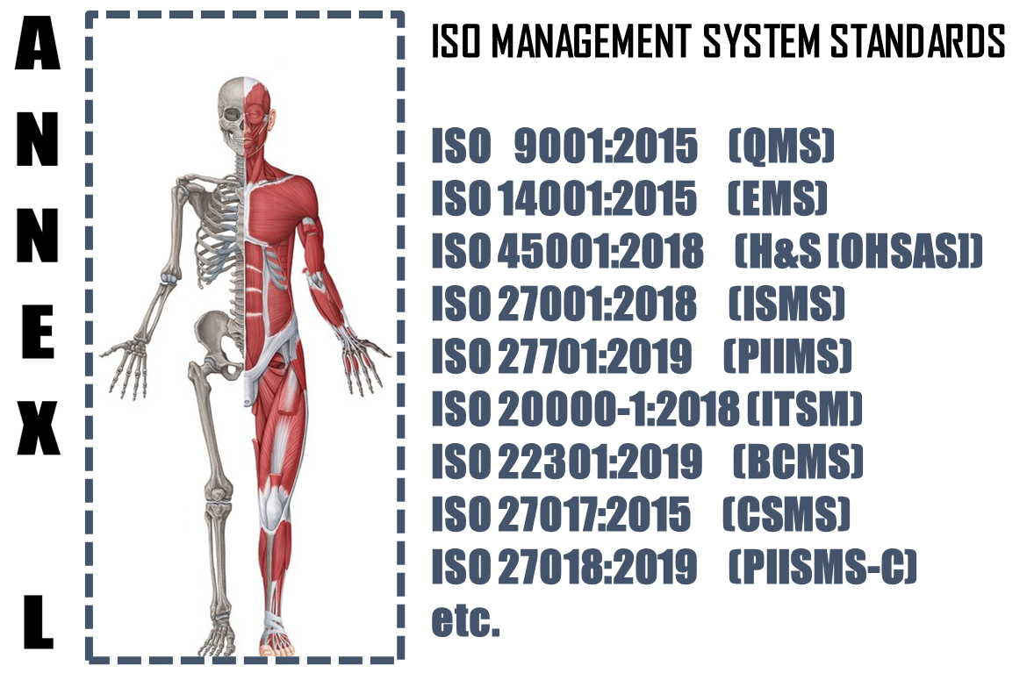

The **Annex L** (now renamed as Annex L in the 2019th edition from Annex SL) is a section of the ISO/IEC Directives part 1 that prescribes how ISO Management System Standard (MSS) standards should be written. The aim of Annex L is to enhance the consistency and alignment of MSS by providing a unifying and agreed-upon high level structure, identical core text and common terms and core definitions. The aim being that all ISO Type A MSS (and B where appropriate) are aligned and the compatibility of these standards is enhanced.

So in short we can say that Annex L is the Skeleton of ISO Management Systems and all standards are now aligned as per Annex L and all the common elements terms and definitions have also been standardized. This has been done to bring in Standard in the Structure, which was not the case in the past, though the intention was the same. So we can say, out of Intent and Content of MS, Content has undergone a change, in the form of Anne L.

What to do in Implementing Environmental Management System?

Based on the Scope and Context, following activities have to be performed in logical sequence. These guidelines given below are only basic milestones and a lot of activities may have to be streamlined as per the standard, based on Scope & Context.

|  |  |  |  |  |
| --- | --- | --- | --- | --- |
| **Step #** | **Requirement of EMS** | **What needs to be done** | **In what way IRCBO can contribute** | **Tools Recommended** |
| 1 | Defining & Documentation | * Defining & Documenting Scope (Technical [Product/Services] and Territorial Scope (# Locations) where the MS is needed. The Org. Management decides the specific scope in line with Applicable regulations * Defining the External & Interested Parties, their business relationship with Org. (in relevance to scope), Identification of critical processes, Information. * All relevant policies and procedures for delivery of products and services, as per scope & context - these procedures or process documents for each interested party activities shall include acceptance criteria as well – including Design of Product/Service Processes; | IRCBO’s Qualified & Experienced consultants can help you in designing, defining, Implementing, monitoring and Improving the MS.  Note: Our contracts can also be associated after Certification for Maintenance of Management System through our digitized tool contributions – aim is to make any MS a plug and play for most effective Controls & Complying (including Legal Compliances) | IRCBO Tool Kit which includes all solutions for Implementation and backed up by IRCBO Designed Software in cloud for :   * Online training   (including  Induction for new employees, awareness & unlimited Internal Auditor Training & Qualification   * Online Internal Auditing Software – this also includes tracking of corrective actions |
| 2 | Implementation | * Implementing all policies and procedures as per EMS defined system; * Assigning and plying Responsibilities and Authorities in more transparent manner; * Participating in Risk Mechanism and approving Residual Risk and EMS Incident investigations; * Focusing on Increasing Competency, * Maintaining good discipline in demonstrating Leadership and aiming for improvements through Management Review platforms; |
| 3 | Periodical Review | * Monitoring, measuring and performing Analysis to ensure * Considering Internal Audit Findings seriously for Timely Corrective Actions in effective manner and take decisions to improve in Management Reviews |
| 4 | Continual Improvement | Implement all actions of Management Review and aim for Continual Improvement – remember Improvement & Continual Improvement are different Concepts |